Student Guide

March 2019

Information in this document, including URL and other Internet Web site references, is subject to change without notice. Unless otherwise noted, the example companies, organizations, products, domain names, e-mail addresses, logos, people, places, and events depicted herein are fictitious, and no association with any real company, organization, product, domain name, e-mail address, logo, person, place or event is intended or should be inferred. Complying with all applicable copyright laws is the responsibility of the user. Without limiting the rights under copyright, no part of this document may be reproduced, stored in or introduced into a retrieval system, or transmitted in any form or by any means (electronic, mechanical, photocopying, recording, or otherwise), or for any purpose, without the express written permission of Microsoft Corporation.

Microsoft may have patents, patent applications, trademarks, copyrights, or other intellectual property rights covering subject matter in this document. Except as expressly provided in any written license agreement from Microsoft, the furnishing of this document does not give you any license to these patents, trademarks, copyrights, or other intellectual property.

The names of manufacturers, products, or URLs are provided for informational purposes only and Microsoft makes no representations and warranties, either expressed, implied, or statutory, regarding these manufacturers or the use of the products with any Microsoft technologies. The inclusion of a manufacturer or product does not imply endorsement of Microsoft of the manufacturer or product. Links may be provided to third party sites. Such sites are not under the control of Microsoft and Microsoft is not responsible for the contents of any linked site or any link contained in a linked site, or any changes or updates to such sites. Microsoft is not responsible for webcasting or any other form of transmission received from any linked site. Microsoft is providing these links to you only as a convenience, and the inclusion of any link does not imply endorsement of Microsoft of the site or the products contained therein.

© 2018 Microsoft Corporation. All rights reserved.

Microsoft and the trademarks listed at <https://www.microsoft.com/en-us/legal/intellectualproperty/Trademarks/Usage/General.aspx> are trademarks of the Microsoft group of companies. All other trademarks are property of their respective owners.

Contents

Machine Learning in a Day student guide 1

Abstract and learning objectives 1

Architecture 2

Section 1: Set up a Data Science Virtual Machine (DSVM) on Azure Portal 3

Section 2: Download Telco dataset and create Blob Storage Account and Container access 9

Section 3: Upload CSV file to Blob Storage Container Manually 15

Section 4: Build a clustering unsupervised model in Azure Machine Learning Studio 18

Section 5: Create a logistic regression model in Azure ML Studio 31

Section 6: Export scored dataset with prediction scores from Blob to Power BI Desktop 39

# Machine Learning in a Day student guide

## Abstract and learning objectives

In this workshop, you will build a Machine Learning model that will be used to predict whether customers remain with business or move onto other services based on their behavior, demographics, and spending. You will leverage several Microsoft products and services on Microsoft Azure to deliver the Machine Learning Model.

The dataset that will be used in the workshop contains the following information

1. Customers who left within the last month – the column is called **Churn**
2. Services that each customer has signed up for
   1. Phone
   2. Multiple lines
   3. Internet
   4. Online security
   5. Online backup
   6. Device protection
   7. Tech support
   8. Streaming TV and movies
3. Customer account information
   1. How long they’ve been a customer
   2. Contract
   3. Payment method
   4. Paperless billing
   5. Monthly charges
   6. Total charges
4. Demographic information about customers
   1. Gender
   2. Age range
   3. If they have partners and dependents

## Architecture

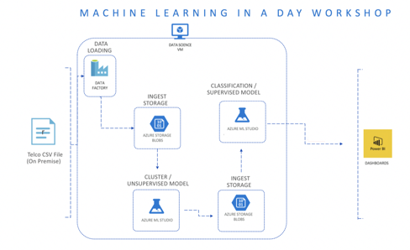

## Section 1: Set up a Data Science Virtual Machine (DSVM) on Azure Portal

1. The use of this documentation requires the subscription of a Microsoft Azure account either from a personal email account or a work email account.
2. Visit [portal.azure.com](http://www.portal.azure.com) and click on **Create a resource** on the left-hand side and type in **Data Science Virtual Machine – Windows 2012** and select the **Create** button as seen in the following screenshot:

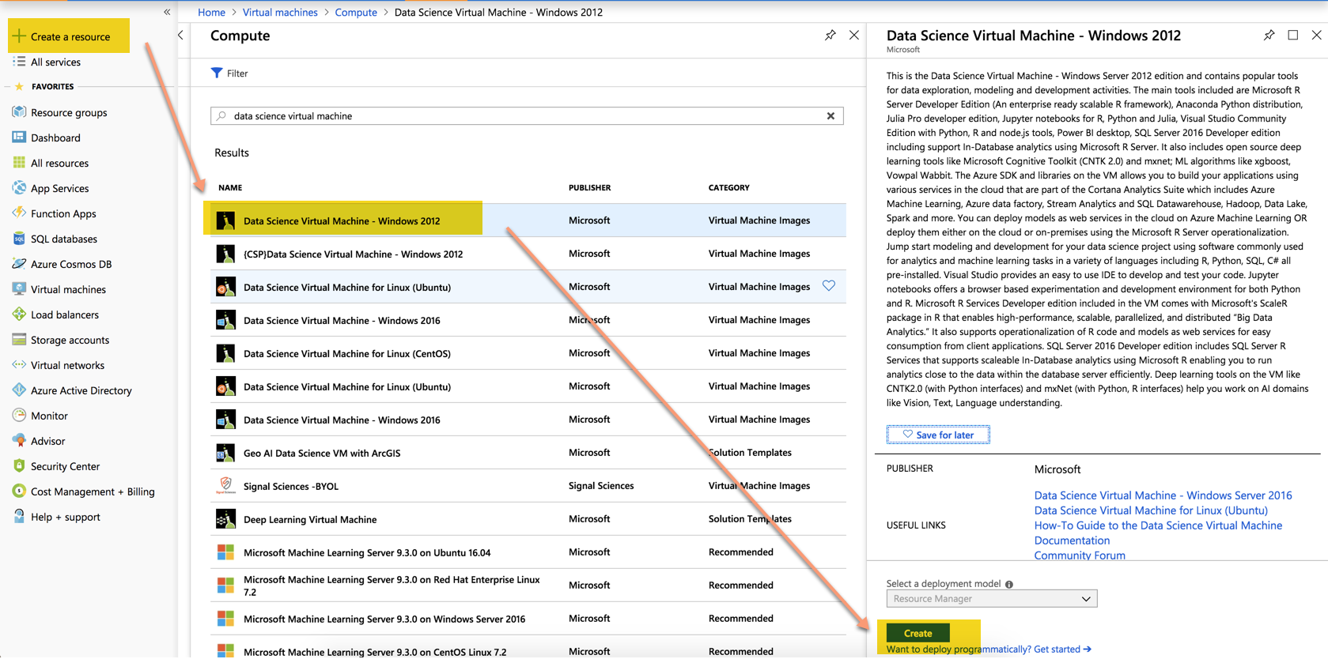

1. Assign the following basic configuration settings for your Data Science Virtual Machine and the select the **OK** button as seen in the following screenshot.

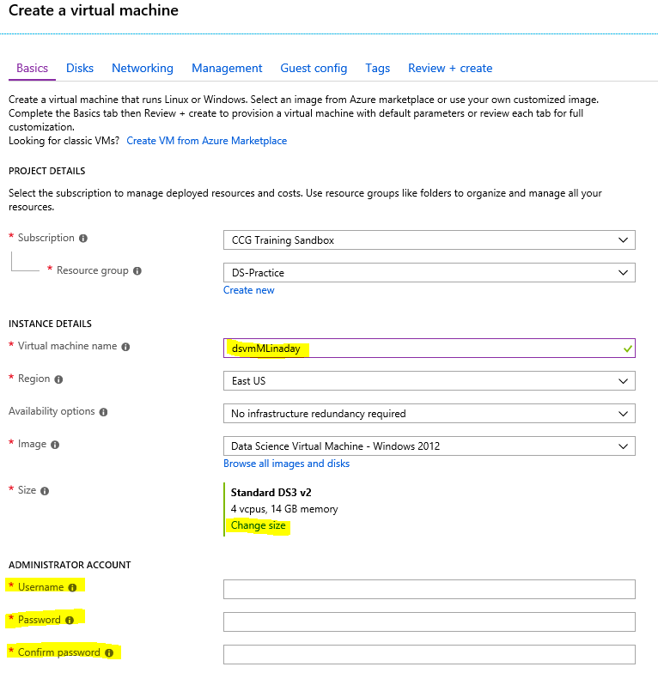

Please note that you can keep your Names and passwords different from this document as long as you remember what you used for future use. In this section, we will assign a username of **demouser** and a password of **#MLinaDay20!9** (Please keep track of both the Username and Password as you will need both of them several times as we go through future sections of this workshop).

1. After clicking “Change size,” choose the following size VM (**D2S_v3**) for the purposes of this workshop as seen in the following screenshot:

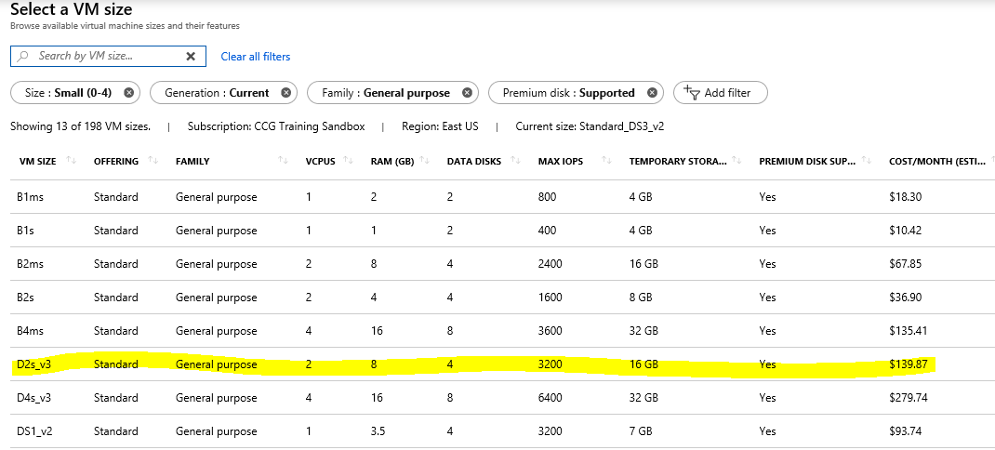

1. For settings, the only configuration that is truly needed is to navigate to the Management tab and enable **auto-shutdown** every evening at **7pm EST** (your manager will thank you later on !!!!) and then select **Review + create** as seen in the following screenshot:

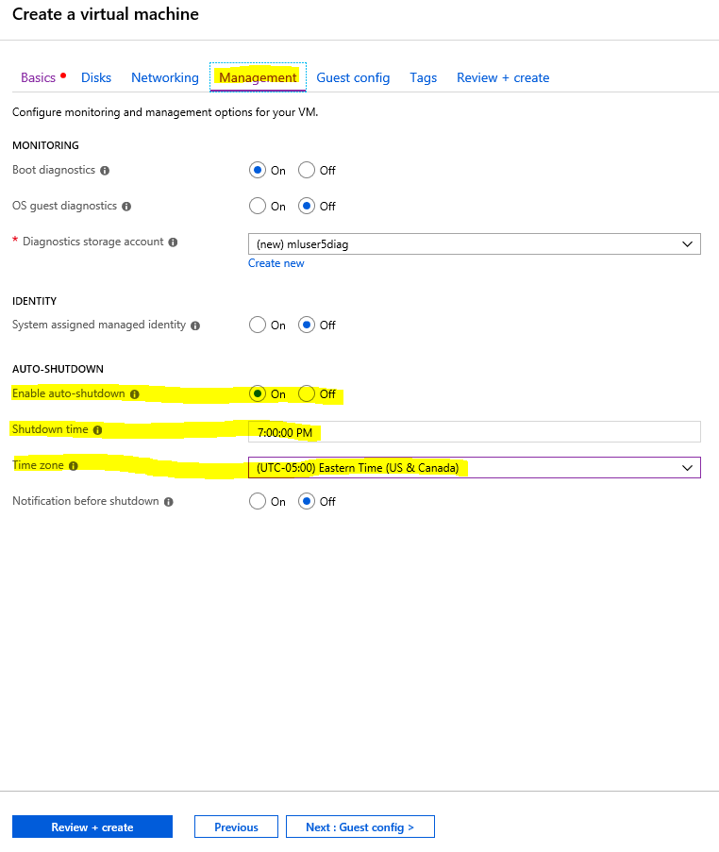

1. In the summary section and confirm everything that was selected is accurate and let the provisioning process of the DSVM begin by clicking on **Create** as seen in the following screenshot:

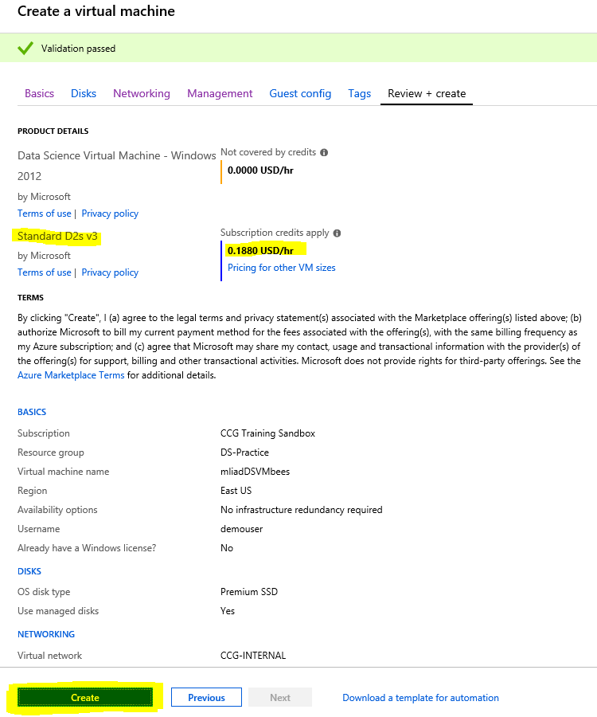

1. Once the provisioning is complete, you can go to your resource and view your DSVM overview and obtain your **Public IP address** as seen in the following screenshot:

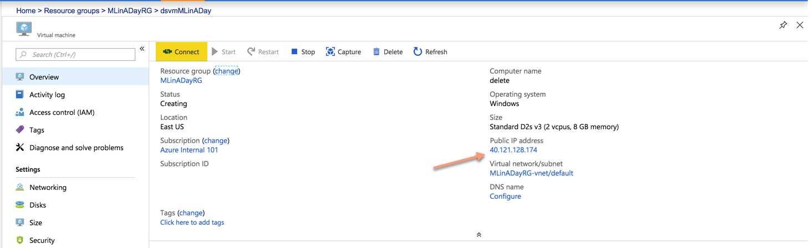

1. Make sure that your DSVM is currently running and click on the **Connect** button to enter your virtual machine using **RDP** as seen in the following screenshot:

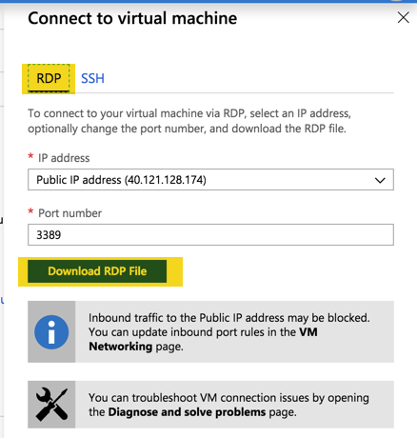

1. Enter your login credentials that were created back in Step # 3 as seen in the following screenshot:

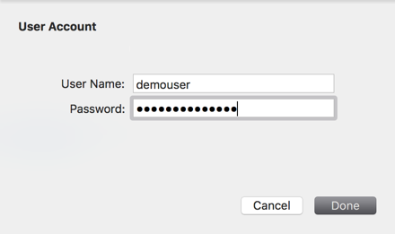

1. It may take a few extra moments while your profile is being created and you will see the following window:

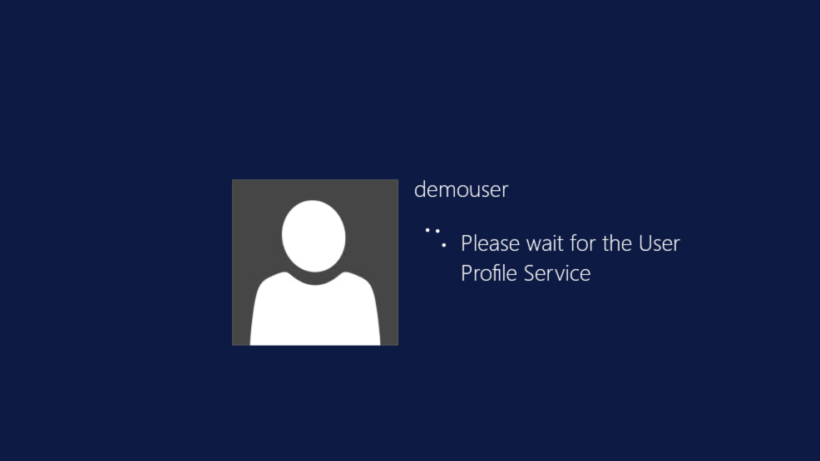

1. Once you log in using your credentials using the RDP approach, you should see the following remote server for the data science virtual machine as seen in the following screenshot:

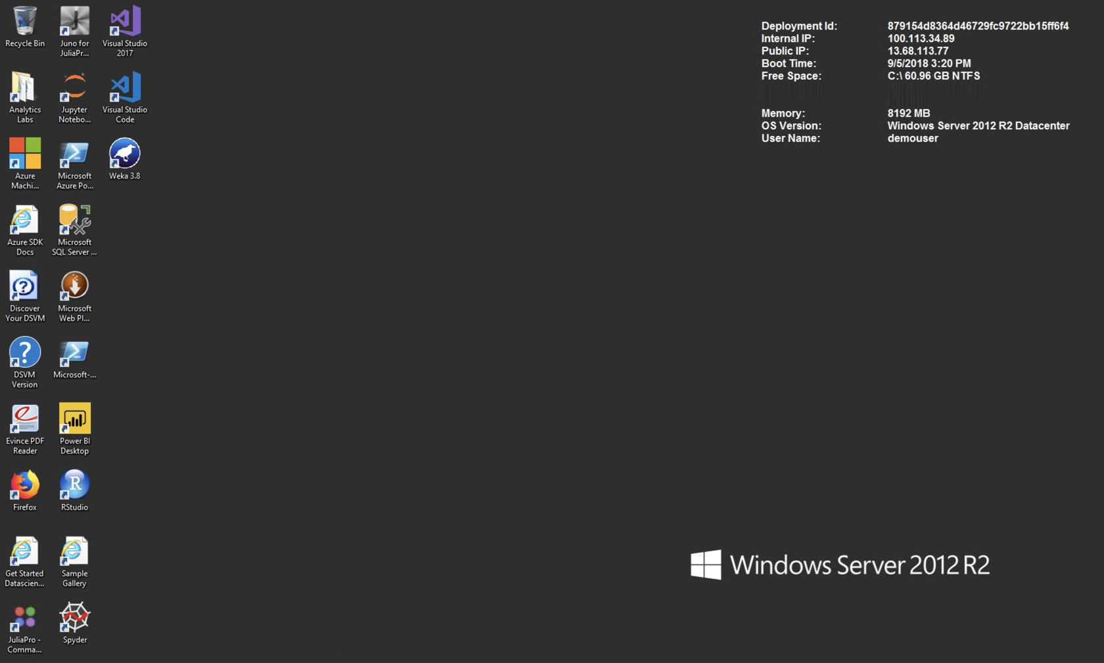

## Section 2: Download Telco dataset and create Blob Storage Account and Container access

1. The Telco Churn Dataset (Telco_Customer_Churn.csv) can be accessed through the following link: <https://raw.githubusercontent.com/asherif844/MachineLearningInADay/master/Files/Telco_Customer_Churn.csv>

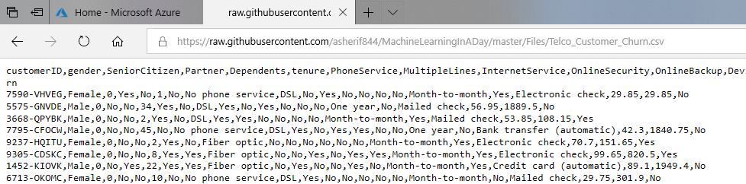

1. Place your cursor in the screen and press Ctrl + A to select all the text. Next press Ctrl + C to copy all the text.
2. Open a new notepad editor by clicking your windows menu, typing Notepad, and selecting the Notepad application when it appears in the search results.
3. In your new Notepad window, press Ctrl + V to paste the data.
4. Select **File** and **Save As…**
5. For now, the dataset can be saved in the C:\ drive as seen in the following screenshot. Be sure to end the file name with **.csv** to specify what type of data the file contains.

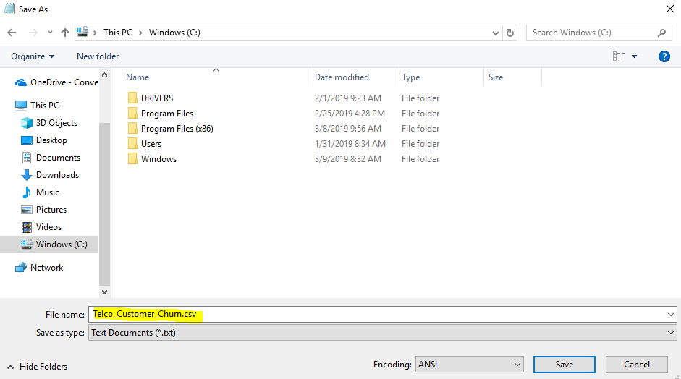

1. Next, we will return to our Azure portal (<https://portal.azure.com>) and create a Blob storage account to house our data. We can do this by selecting **Create A Resource**, typing **Blob** in the search, and then selecting **Storage Account** as seen in the following screenshot:

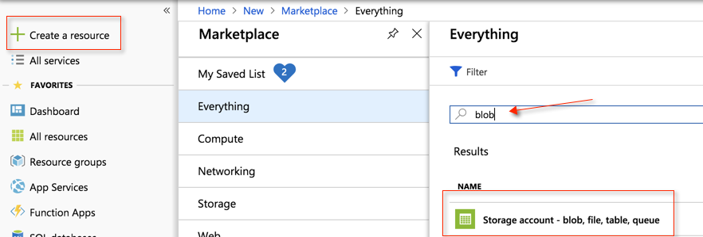

1. Once you create a **Blob** account, you can name and customize the properties of the account as the following, for optimal performance in this workshop (Please note than any existing resource that is created from this point forward in the workshop should ideally use the same existing **Resource Group** that we created in Section 1):

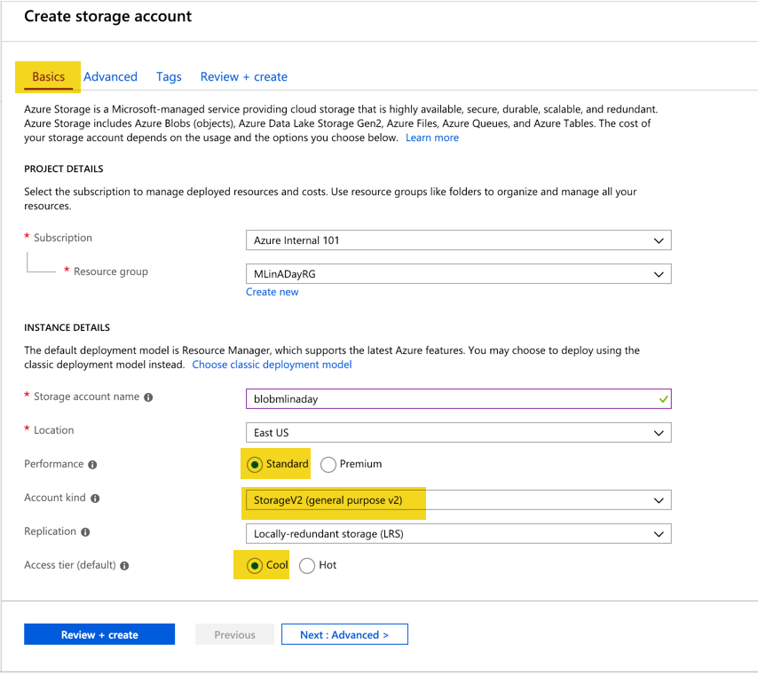

1. Ensure that the Basics setting includes **Standard** Performance, **StorageV2** Account Kind, **Locally-redundant storage**, and **Cool** Access Tier.
2. Continue on to the Advanced Section of the settings and ensure that **secure transfer required** has been disabled as seen in the following screenshot:

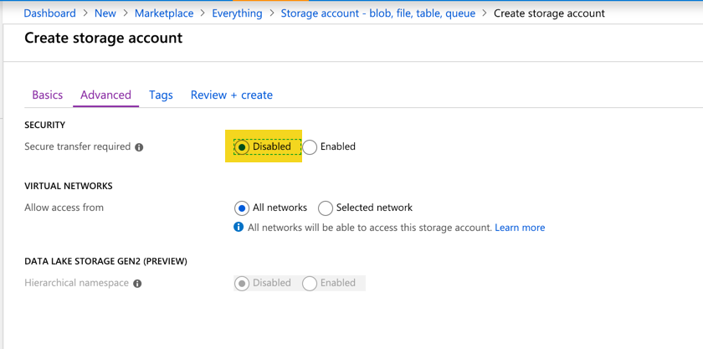

1. Next, we can just click on **Review and Create** and ensure that our validation has passed as seen in the following screenshot:

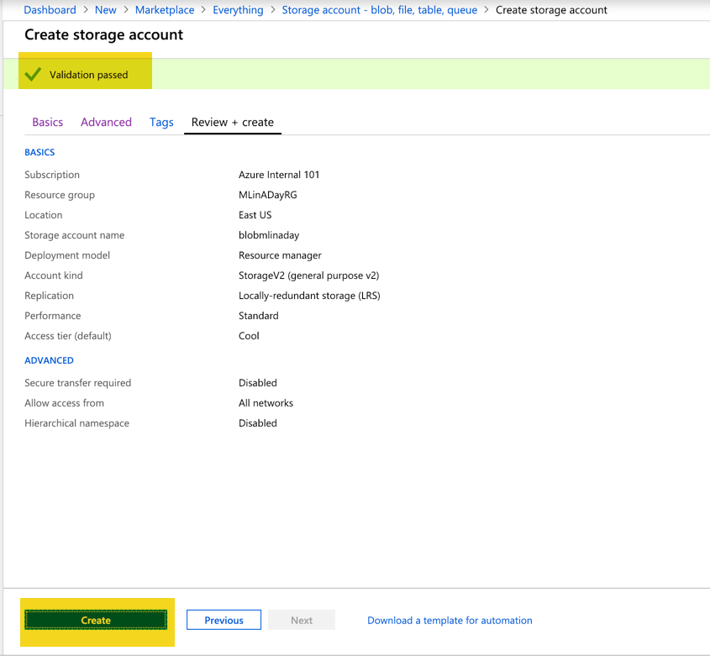

1. We can then just click on **Create** and begin the deployment process of the blob storage.
2. While the deployment is underway, we can check the progress as seen in the following screenshot:

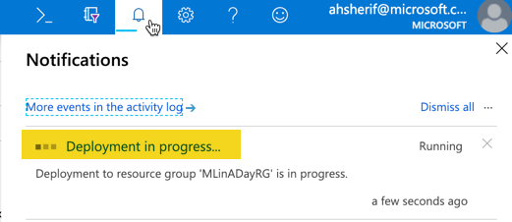

1. Once the Blob account has been successfully deployed, we can go to the storage account by clicking on **Go to Resource**, as seen in the following screenshot:

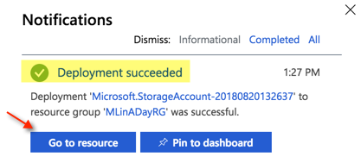

1. ****Important Step ***** Ensure that your blob account has the following setting configured to ensure that **Secure Transfer Required** is **Disabled** by selecting Configuration as seen in the following screenshot:

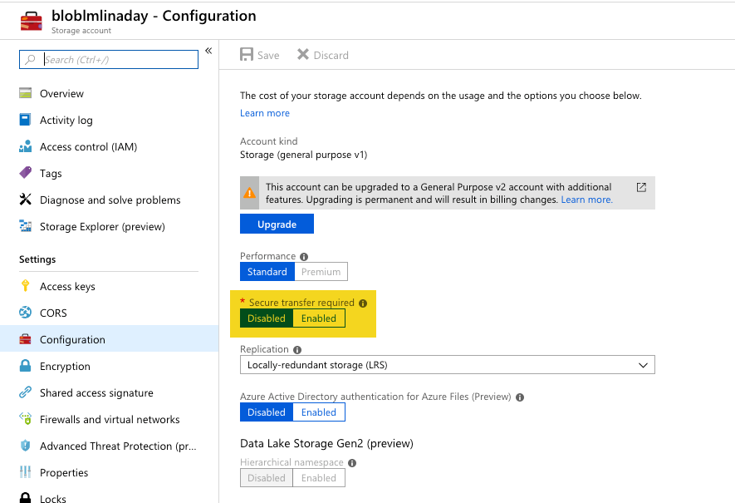

1. Back in the Overview section, select **Blobs** under the **Services** section as seen in the following screenshot:

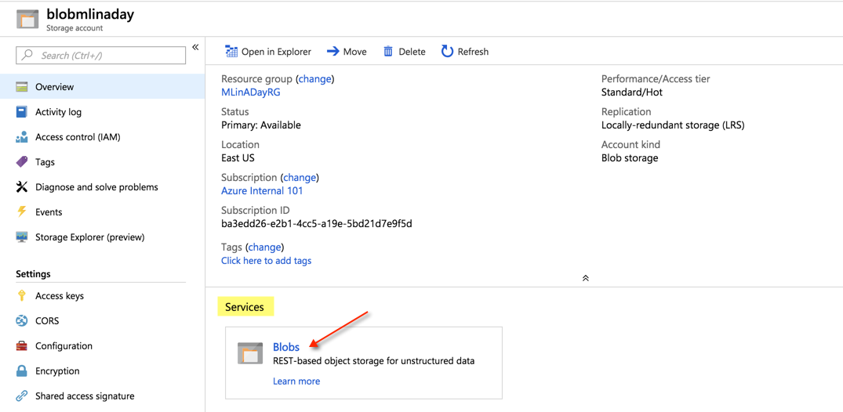

1. We should now be in the Containers section; however, if this is the first time, we are entering the Container, we should see a message that says **You don't have any containers yet. Click '+ Container' to get started**.
2. Go ahead and create a new Container called **Churn** and set **Public access level** to **Container (anonymous read access for containers and blobs)**, as seen in the following screenshot:

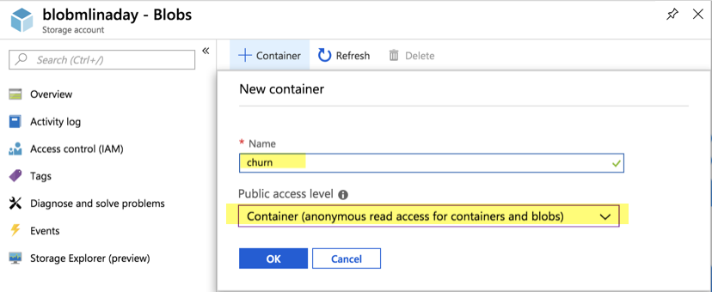

1. The only thing that we will need right now is an **Access Keys** that will be used in future sections of this workshop. We can copy **key1** and paste it somewhere handy in a notepad editor as seen in the following screenshot:

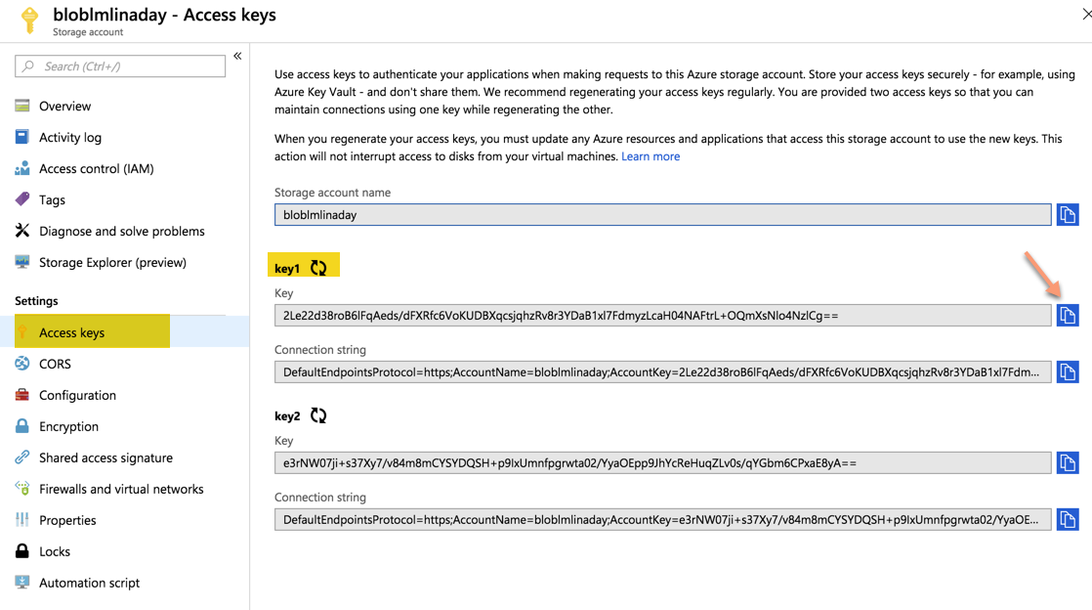

1. Once the container has been successfully created, we can move onto the next section of adding data to the container. We’ll do it manually to keep this workshop simple.

## Section 3: Upload CSV file to Blob Storage Container Manually

1. Access your blob storage container once again by selecting **Storage Accounts** on the left-hand side of the Portal menu, selecting your Blob account, and finally selecting **Blobs** under **Blob Service** as seen in the following screenshot:

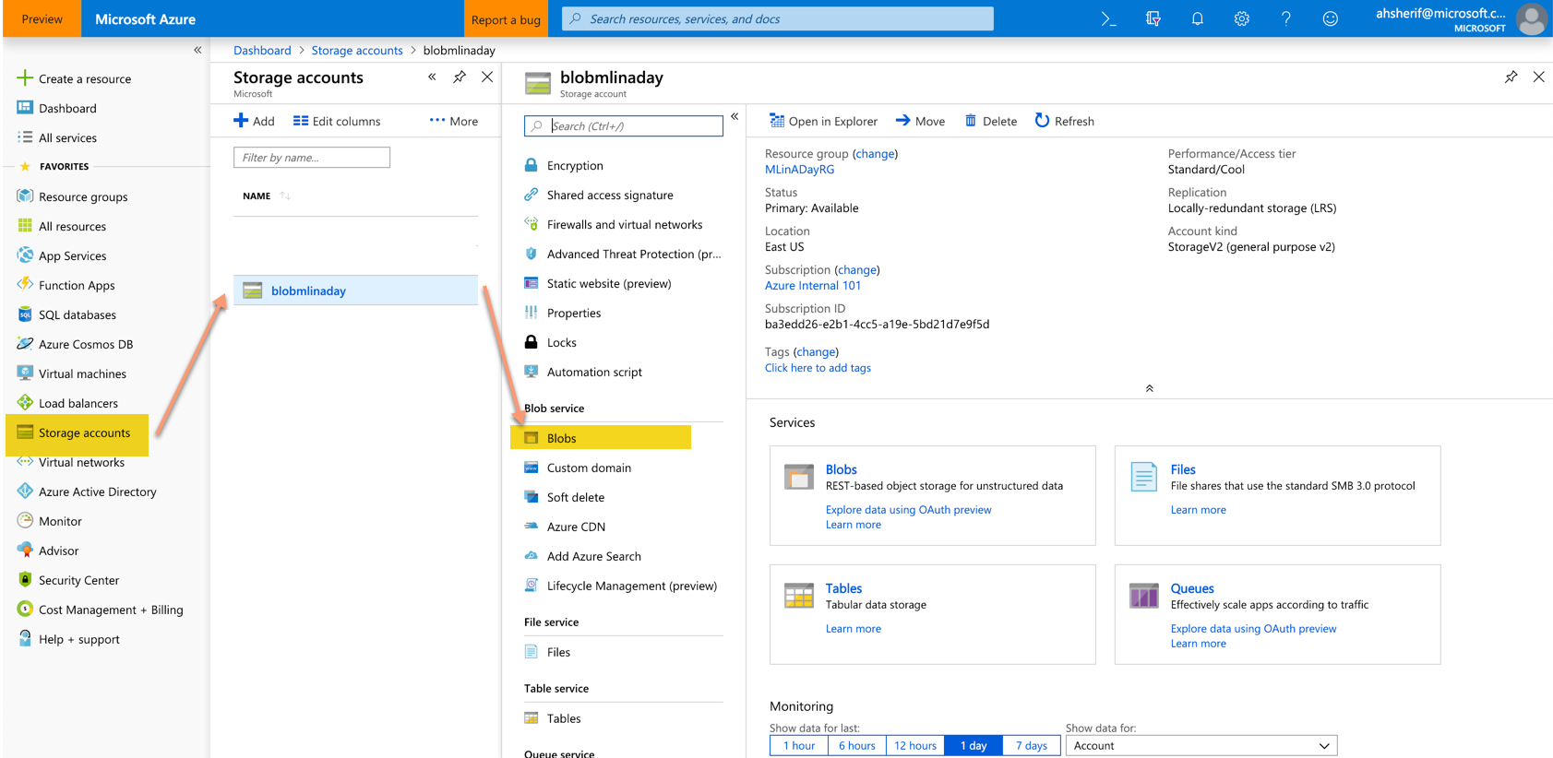

1. Select your **container** which should be called churn as seen in the following screenshot:

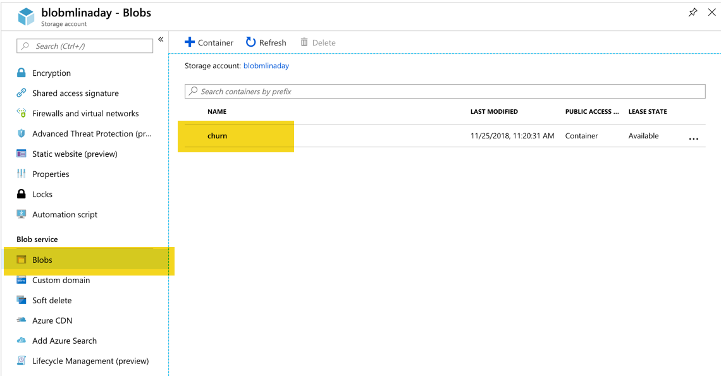

1. Once inside your container, select the upload icon to begin the uploading of your csv spreadsheet as seen in the following screenshot:

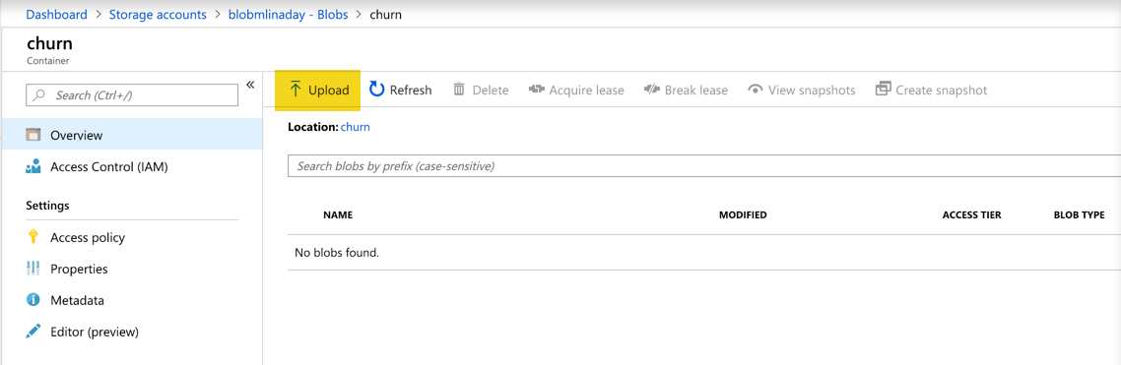

1. Select your file from your local hard drive and select Upload as seen in the following screenshot. The Authentication type option no longer appears in the latest version:

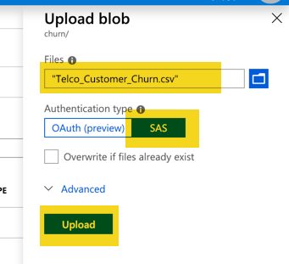

1. You should now see your CSV file in your container as seen in the following screenshot:

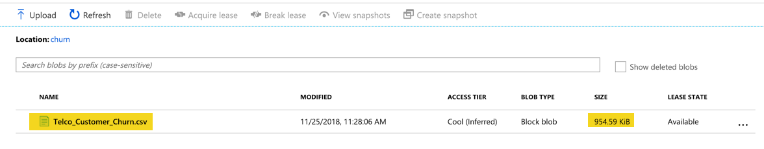

1. Your file should be ~ 955 kB. If you click on your CSV file and select **Edit Blob**, you can preview your actual data that is in the CSV file within the **Blob** container as seen in the following screenshot:

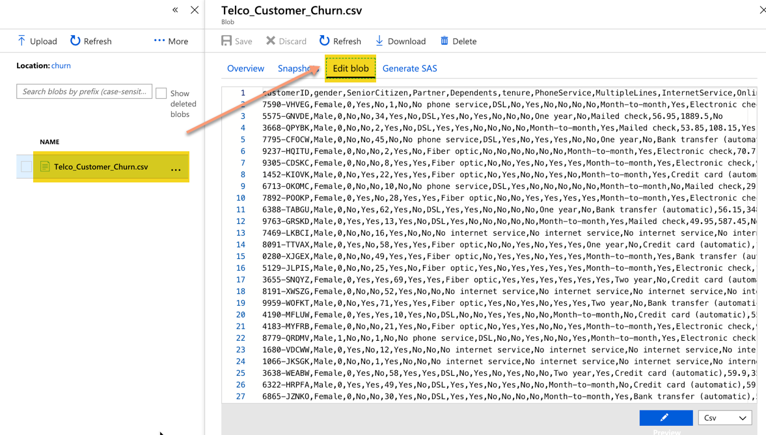

1. We have now confirmed our file is in our Blob account and we can continue onto Section 4.

## Section 4: Build a clustering unsupervised model in Azure Machine Learning Studio

1. Clustering is the process of grouping similar entities together. The goal of this unsupervised machine learning technique is to find similarities in the fields that we have about our customers and group them into 10 distinct clusters.
2. Sign into Azure Machine Learning Studio using your Azure login Credentials in the following website: <https://studio.azureml.net/>
3. If you are not already directed to create a new experiment, go ahead and select the Experiments tab on the menu on the left-hand side as seen in the following screenshot. All current and future experiments will reside in this section.

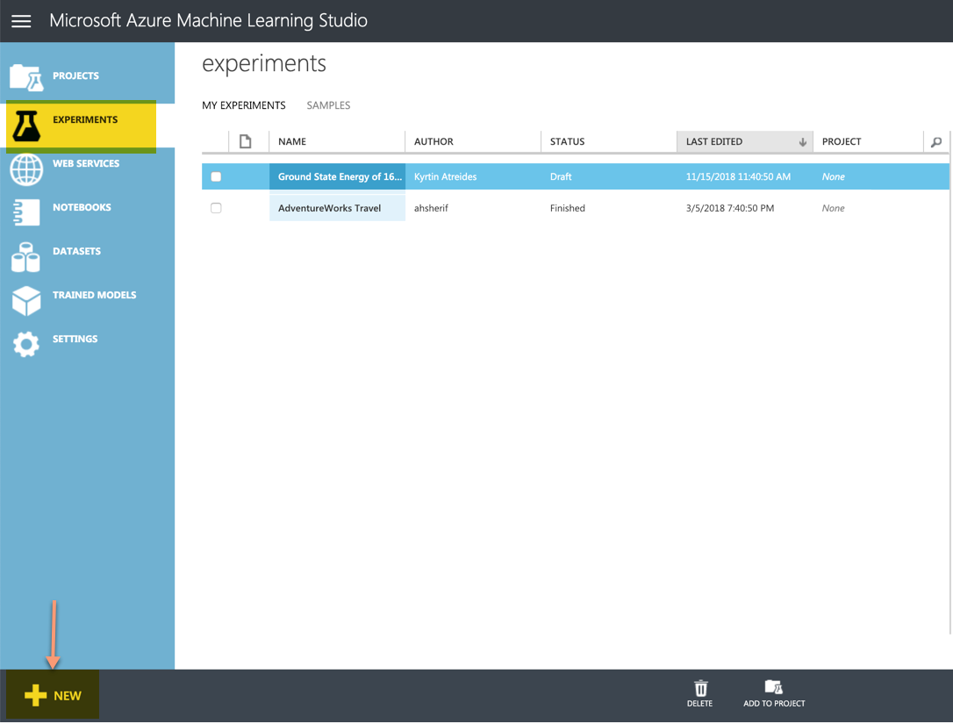

1. Next click on **+NEW** on the button of the screen and select **Blank Experiment** as seen in the following screenshot:

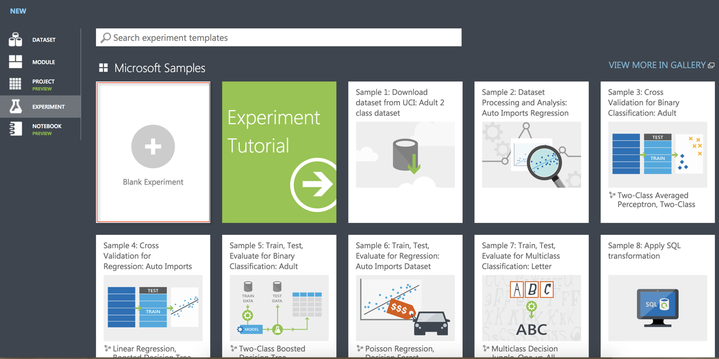

1. Click on the title of the experiment and change the name to **Churn Clustering Unsupervised Model** as seen in the following screenshot:

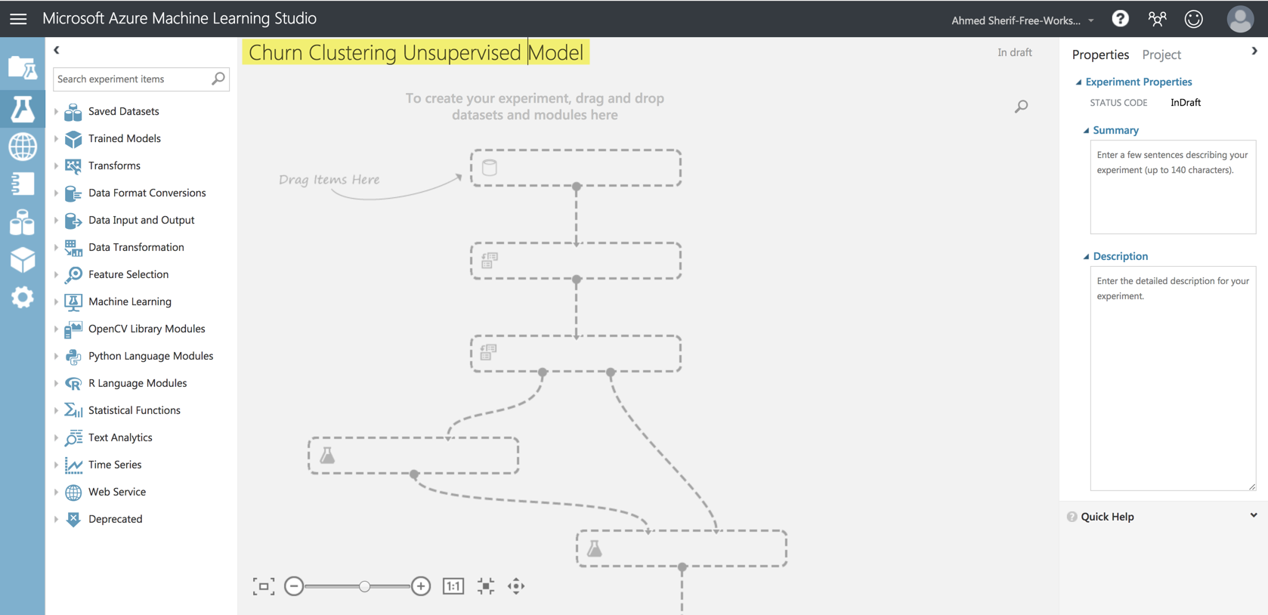

1. Expand the **Data Input and Output** category and drag the **Import Data** into the Workflow as seen in the following screenshot:

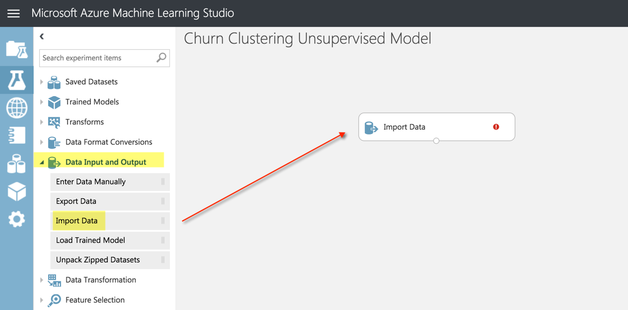

1. As you click on the **Import Data** icon in the workflow, you will have the option to configure your data to pull from the Azure Blob Container you created a few sections ago using the Launch Import Wizard as seen in the following screenshot:

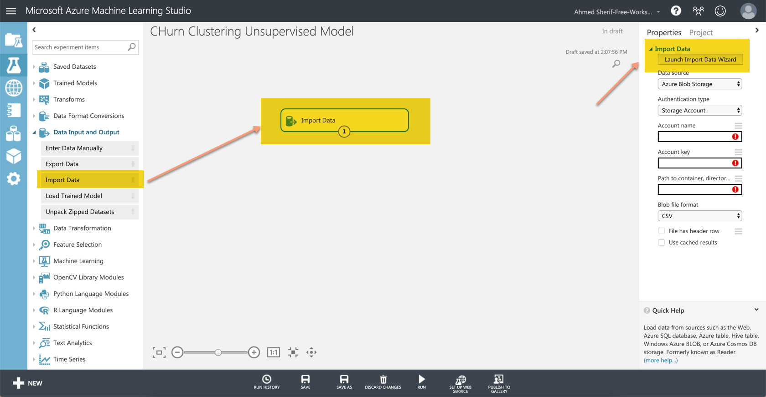

1. Select Azure Blob Storage

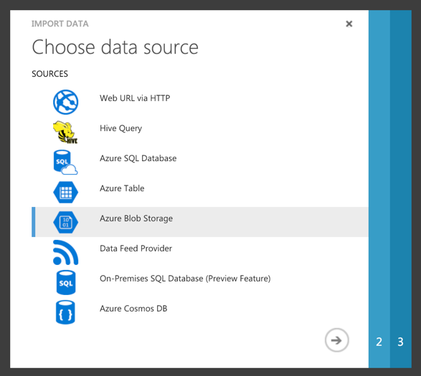

1. Specify the following credentials from the drop-down boxes for your accounts:

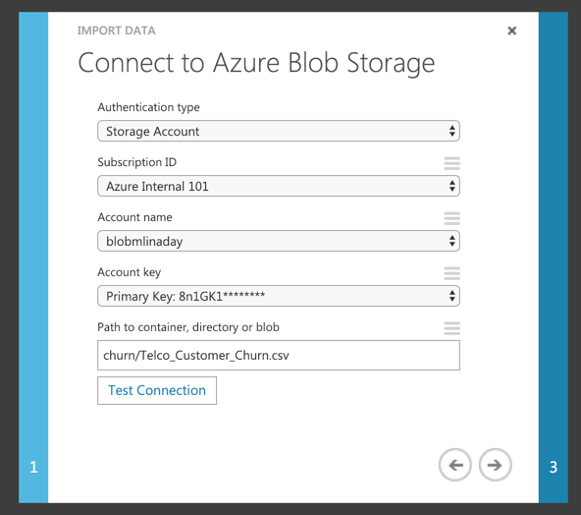

1. Test the connection to make sure the credentials work. Once it is validated you should see a green checkmark as seen in the following screenshot:

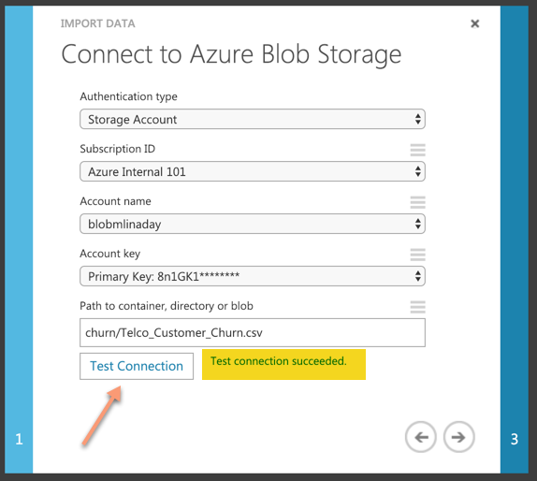

1. Check to include a **file header row** for the data and maintain a **CSV** file structure as seen in the following screenshot:

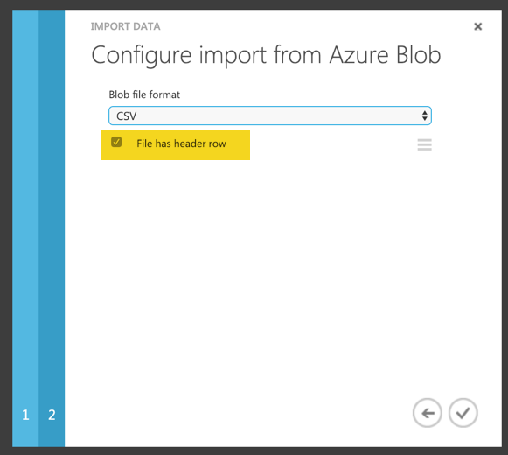

1. Back in the Azure ML Studio workflow, the credentials can be confirmed by clicking on the **RUN** icon at the bottom of the screen and seeing the green check mark next to **Import Data**.

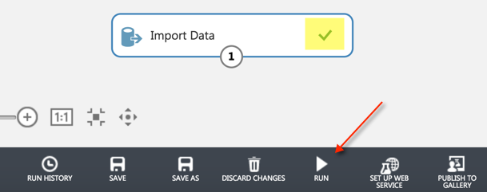

1. ***Every time a new node is added and attached to an existing node, you will need to select the RUN icon to see the new results***
2. Once we have confirmed the connection is working, we can right-click on the number **1** on the first workflow and **Visualize** the dataset as seen in the following screenshot:

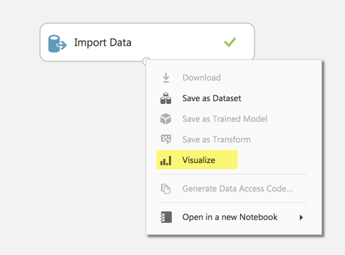

1. Take some time to click on the columns to identify the summary statistics for both the numeric fields and the categorical fields as seen in the following screenshot:

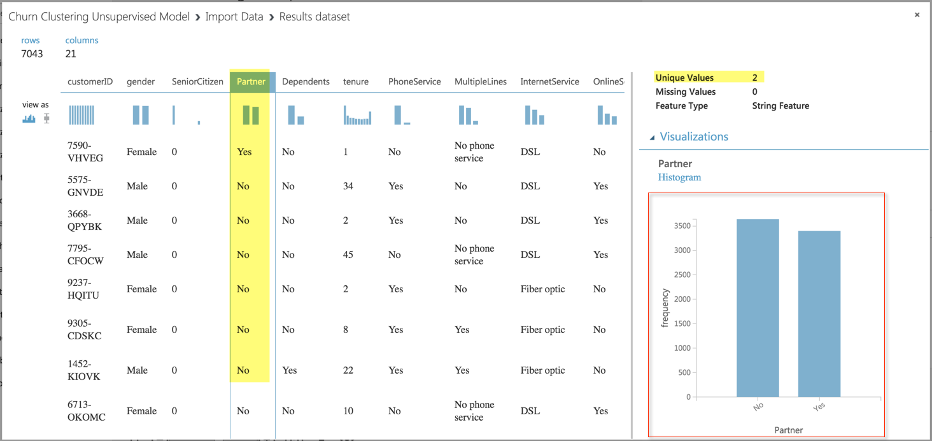

1. Import **Train Clustering Model** from the **Machine Learning** Node and connect it to the **Import Data** module as seen in the following screenshot:

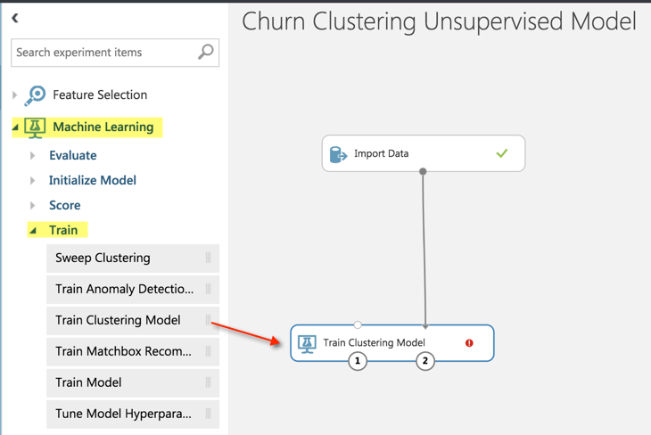

1. Next, click on the **Train Clustering Model** module, **Launch Column Selector**, connect the node back to the **Import Data** node, and configure the columns to be selected as seen in the following screenshot:

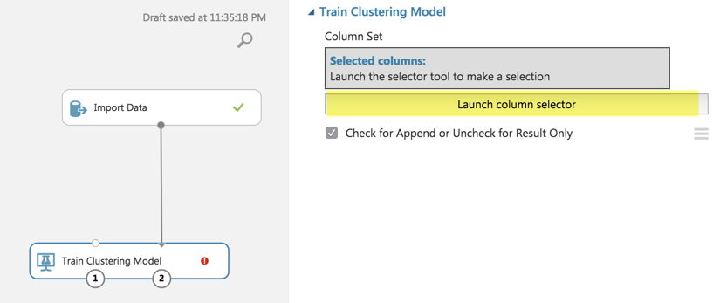

1. **CustomerID** is not a column that will help us out in clustering customers into 1 of 10 categories; therefore, we will remove it from the cluster algorithm. **Churn** is also not helpful, because customers who have churned are no longer customers.
2. So, you will need to configure the **clustering model** and **Select All columns** from the dataset except for the column called **customerID** and **Churn** as seen in the following screenshot:

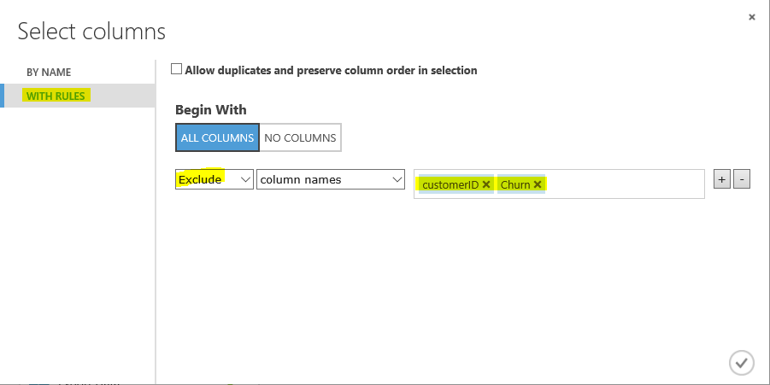

1. Next, we will add a **K-Means Clustering** model from the Machine Learning 🡪 Initialize Model 🡪 Clustering section. Attach it to the **Train Clustering Model** and assign the following parameters to the clustering model, as seen in the following screenshot:

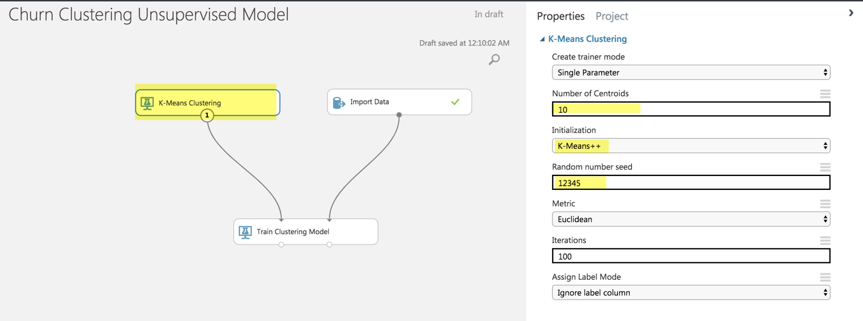

1. Select **RUN**
2. Next, we will do some data cleanup and remove any rows that have missing values by pulling in the **Clean Missing Data** module and connecting it to the **Train Clustering Model** as seen in the following screenshot:

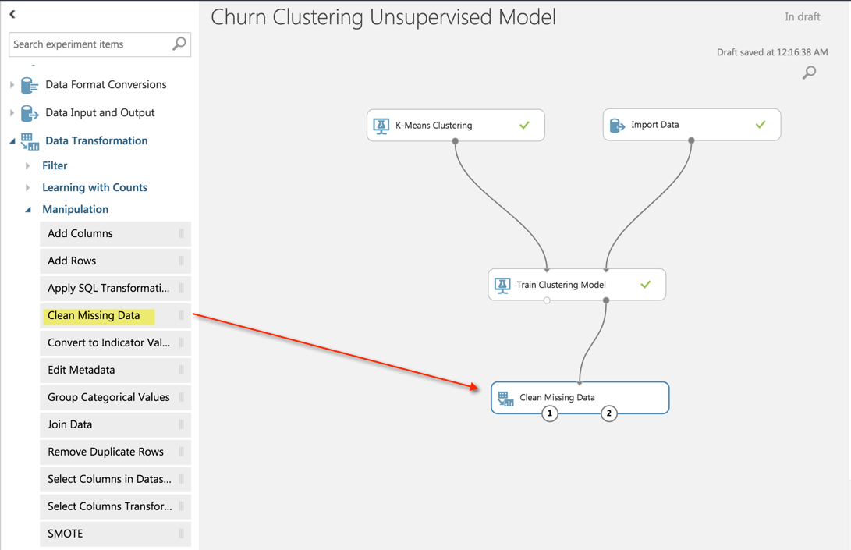

1. We can configure the **Clean Missing Data** module by clicking on it and selecting the following configuration to remove any rows if they meet the following criteria:

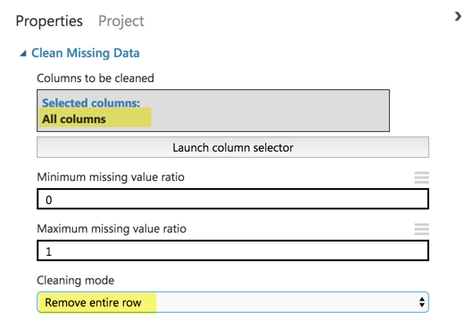

1. Select **RUN**
2. The clustering outcome produces several columns that are not necessary for our purposes for this workshop as can be seen by visualizing the **Clean Missing Data** module as seen in the following screenshot:

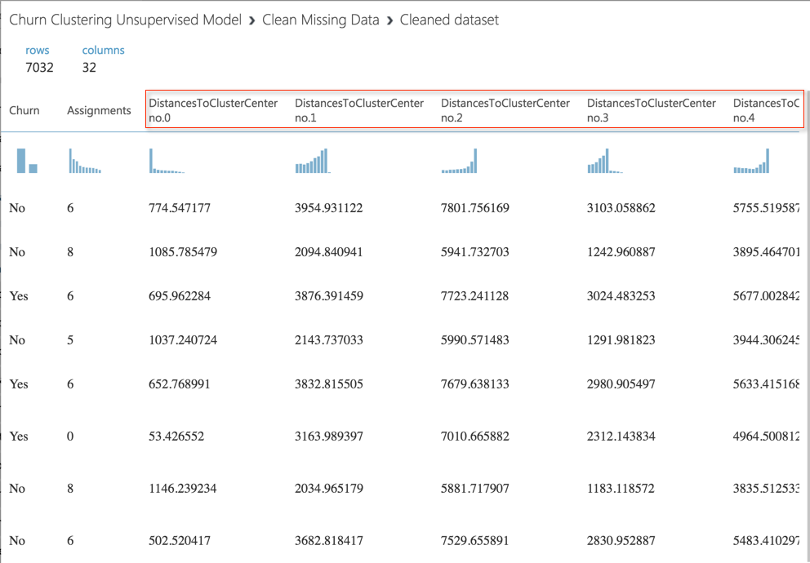

1. We are truly only interested in the assignments, which is grouping each customer into a category of **0** through **9** as seen when we visualize a histogram of the unique values as seen in the following screenshot:

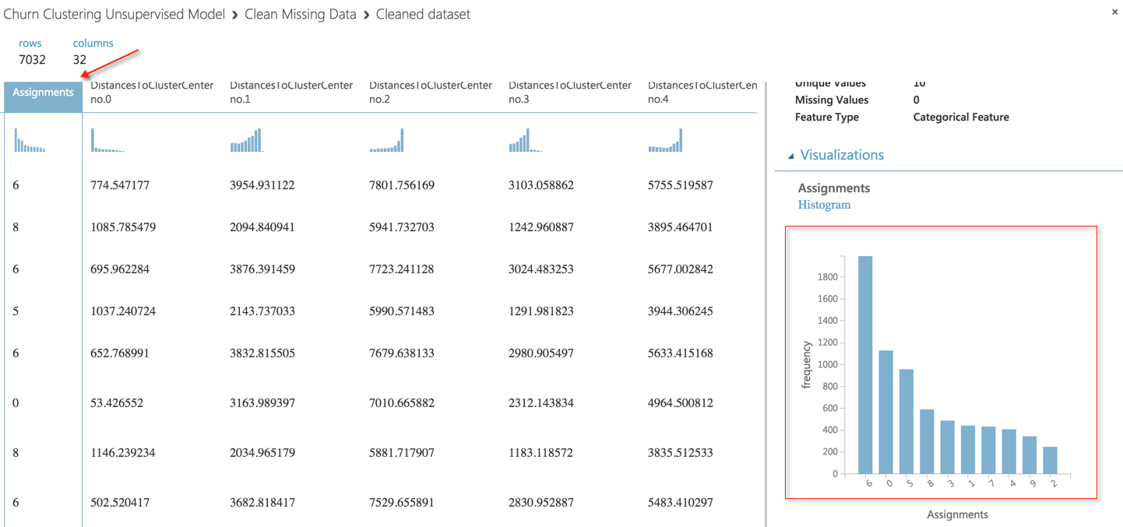

1. All other columns that start with **DistancesToClusterCenter** are not relevant for our purposes and can be removed. The easiest way to do this is to drag into our workflow **Select Columns in Dataset** as seen in the following screenshot:

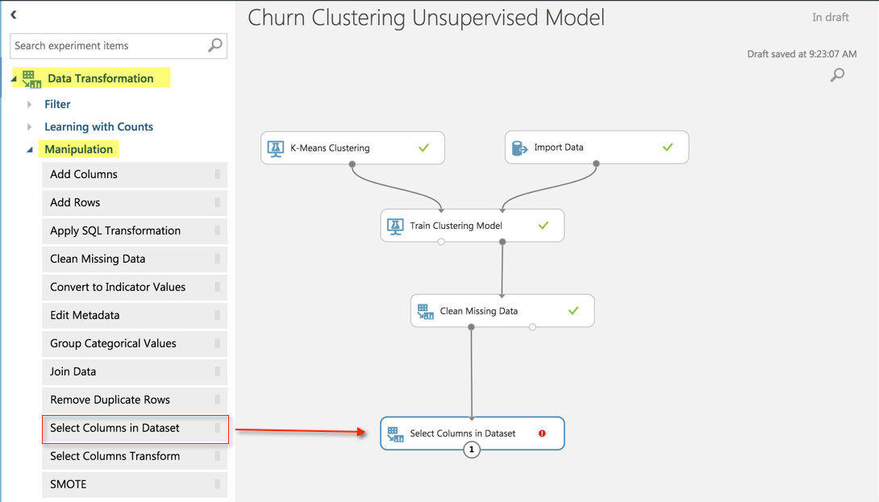

1. We can then configure the module for **Select Columns in Dataset** by **Launching Column Selector**, select WITH RULES, and exclude column names DistancetoClusterCenter no.0 through DistancetoClusterCenter no.9, as seen in the following screenshot:

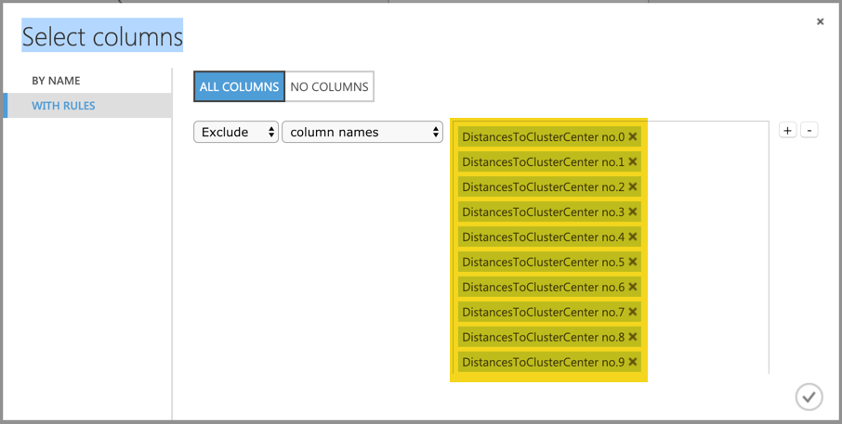

1. Select **RUN**
2. We are finally ready to send out revised dataset with only the columns that we need back to blob storage using the **Export Data** module as seen in the following screenshot:

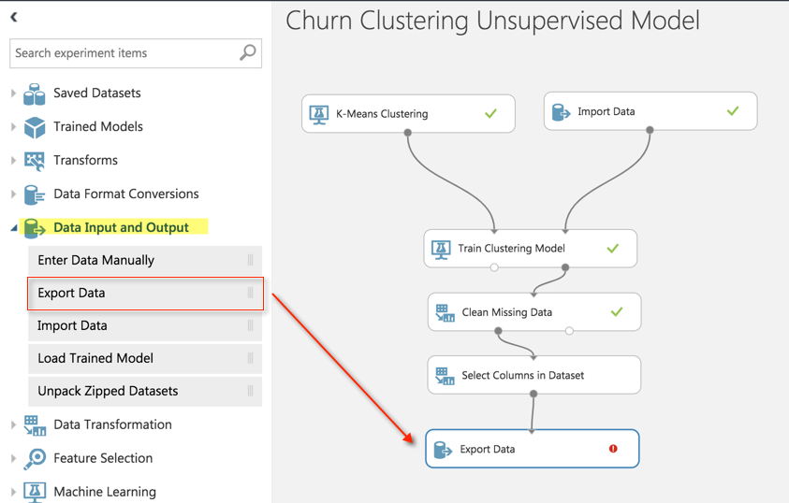

1. Unlike the Import Data module, we do not have a wizard to help us out. So, we will have to input our credentials manually.
2. We will need to configure the connection to export the new dataset, **Telco_Customer_Churn_Cluster.csv**, back to the same blob container, **churn**, using the following configuration as seen in the following screenshot *(please note that you should continue to use the same* ***Key1*** *from Blob storage that was saved to a notepad from an earlier section)*:

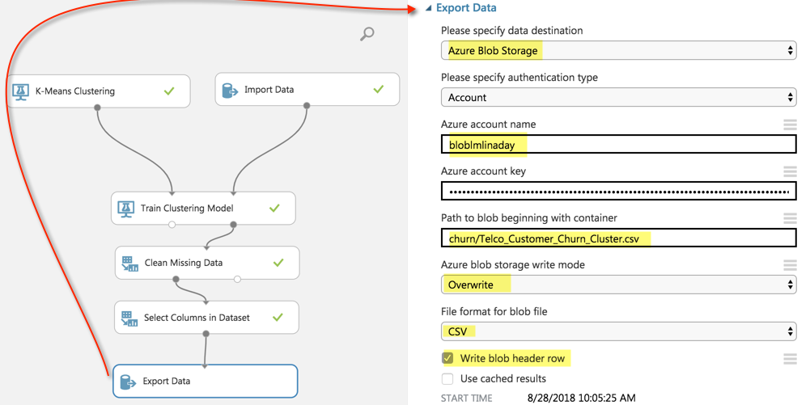

1. Once we are done, we can execute our workflow one last time by clicking on the **RUN** button.
2. Once completed, we should hopefully see all green checkmarks next to each step of our workflow as seen in the following screenshot:

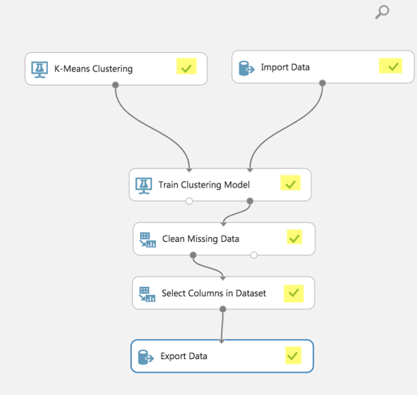

1. We can revisit our Blob container in the Azure Portal and view our newly added dataset alongside our existing dataset as seen in the following screenshot:

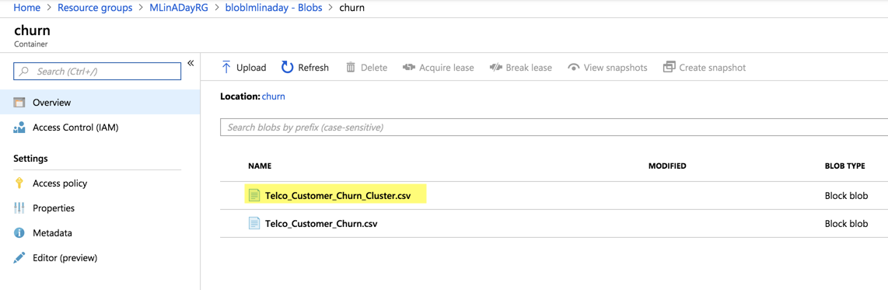

## Section 5: Create a logistic regression model in Azure ML Studio

1. Just as we did in the previous section, we will go ahead and create a new **Blank Experiment** in Azure ML Studio that is named Logistic Regression Churn Model as seen in the following screenshot:

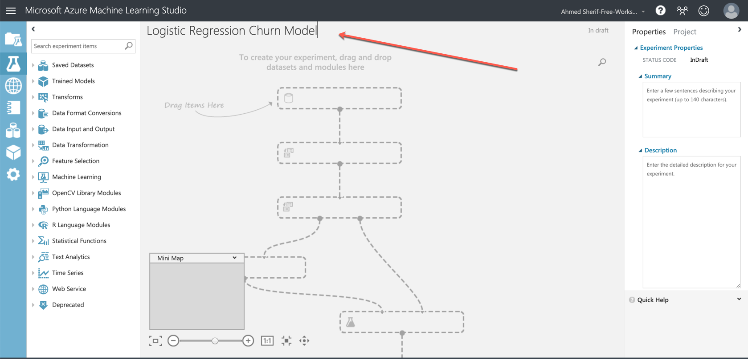

1. Once again, launch the import wizard but this time but this import the **Telco_Customer_Churn_Cluster.csv** file as seen in the following screenshot:

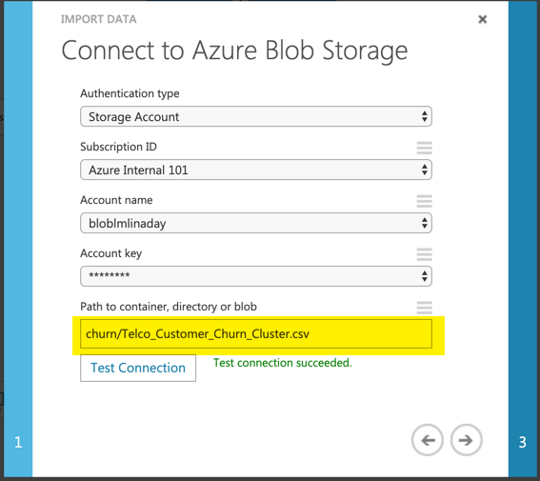

1. Ensure the File has header row and then run the experiment to confirm that the data has exported as seen in the following screenshot:

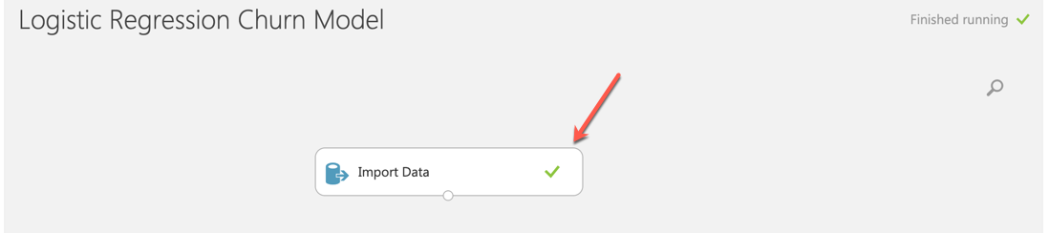

1. We must do some modifications to our numeric fields to normalize them. We only have three numeric fields: **Tenure**, **TotalCharges** and **MonthlyCharges**.
2. Drag the **Normalize Data** node onto the workflow and select **ZScore** transformation to normalize data as seen in the following screenshot:

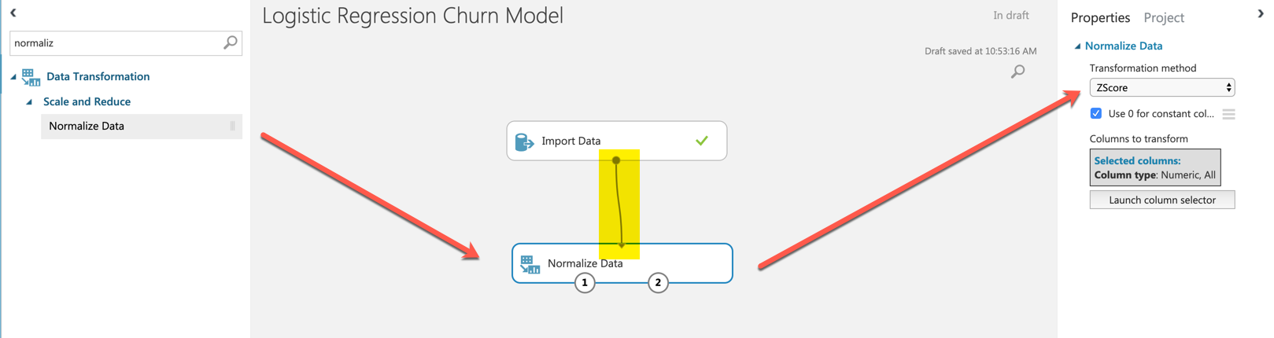

1. Launch the column selector and select Begin with NO COLUMNS and Include only **Tenure,** **MonthlyCharges** and **TotalCharges** as seen in the following screenshot:

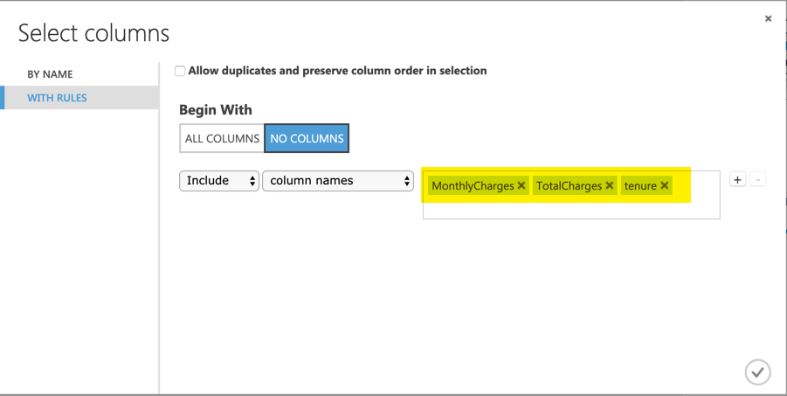

1. Select the check mark and **RUN** the experiment
2. Once the experiment has finished, the values for **Tenure**,**Monthly** **Charges** and **Total** **Charges** have now been normalized as seen in the following screenshot:

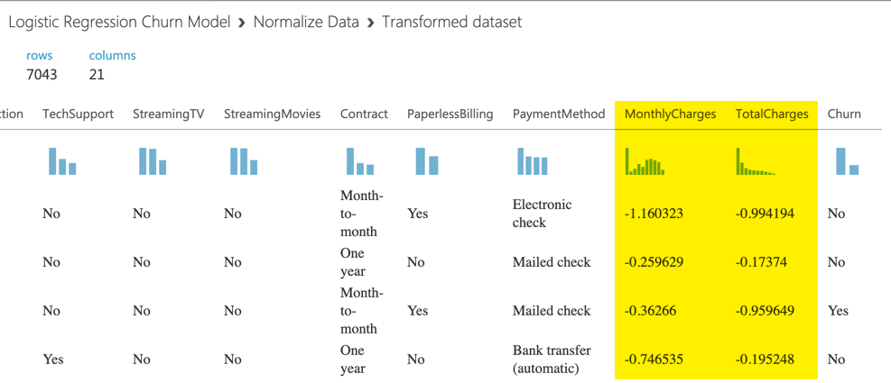

1. **What is a Z-Score. Basically, a Z-Score is a way to compare results to a normal distribution or normal population. It is a way to measure how many standard deviations something is away from the mean, positively or negatively.**
2. We are now ready to split our data into a training and testing split by pulling the **split** **data** node onto the workspace with the following parameters as seen in the following screenshot:

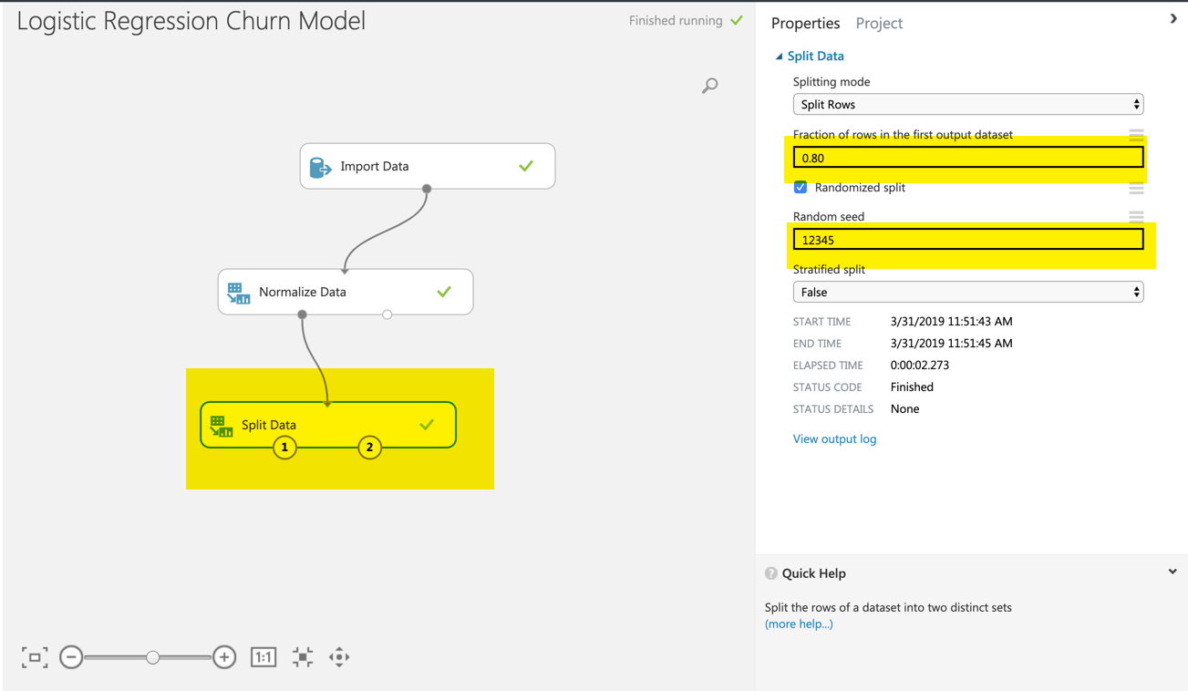

1. Run the experiment
2. Drag a **Train Model** node and connect it to the canvas and select **Churn** as the selected column as seen in the following screenshot:

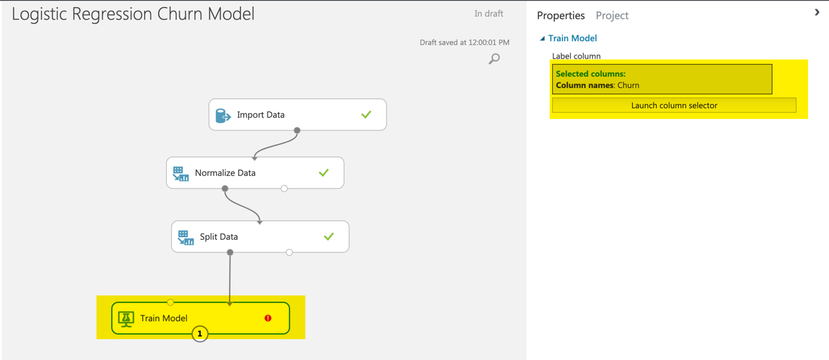

1. Connect the **two-class** **logistic** **regression** node to the top of the **Train** **Model** node and specify a seed as seen in the following screenshot:

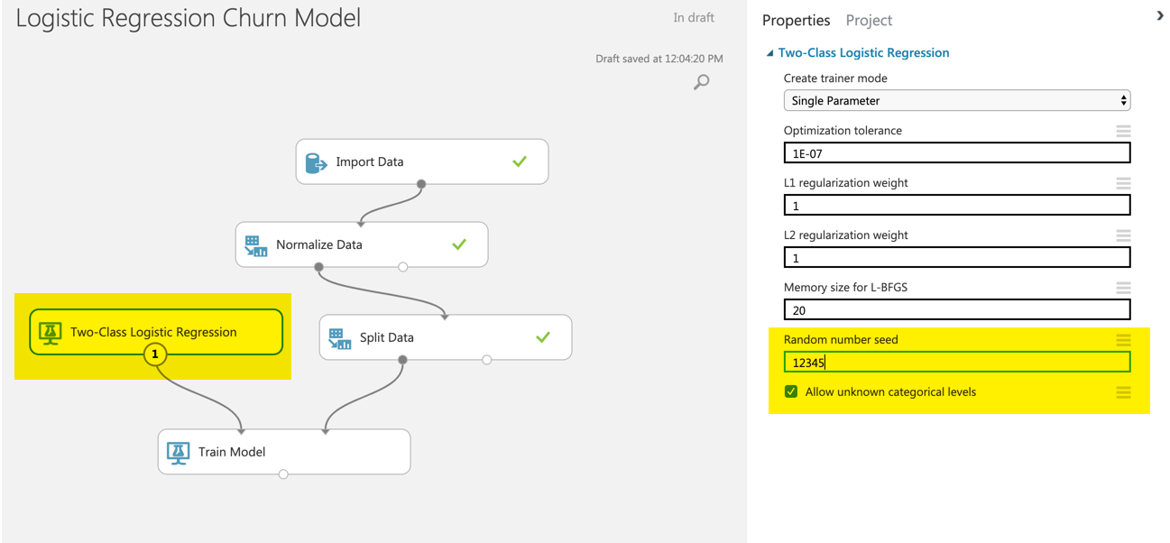

1. We now want to score our model against the test data set that we split earlier on in the section as seen in the following screenshot:

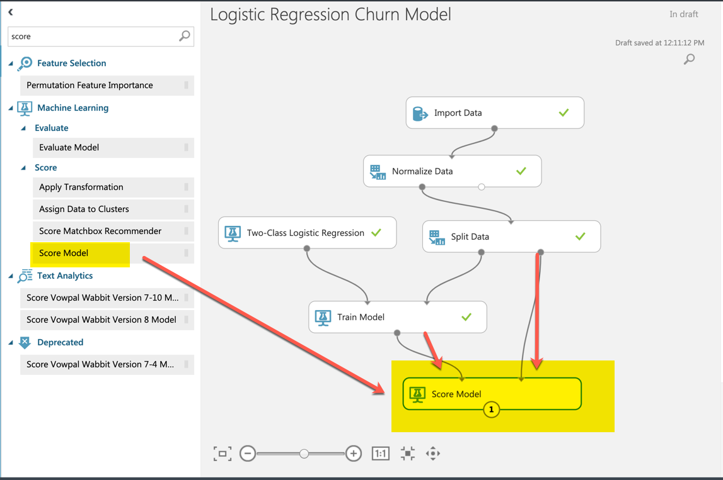

1. Run the experiment
2. If we view the scored model results, we can see how we did compare to what the actual prediction outcome was as seen in the following screenshot:

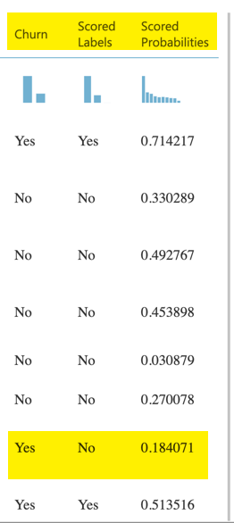

1. Rather than looking at each individual dataset from our dataset, we can evaluate our model as a whole using the **evaluate** node as seen in the following screenshot:

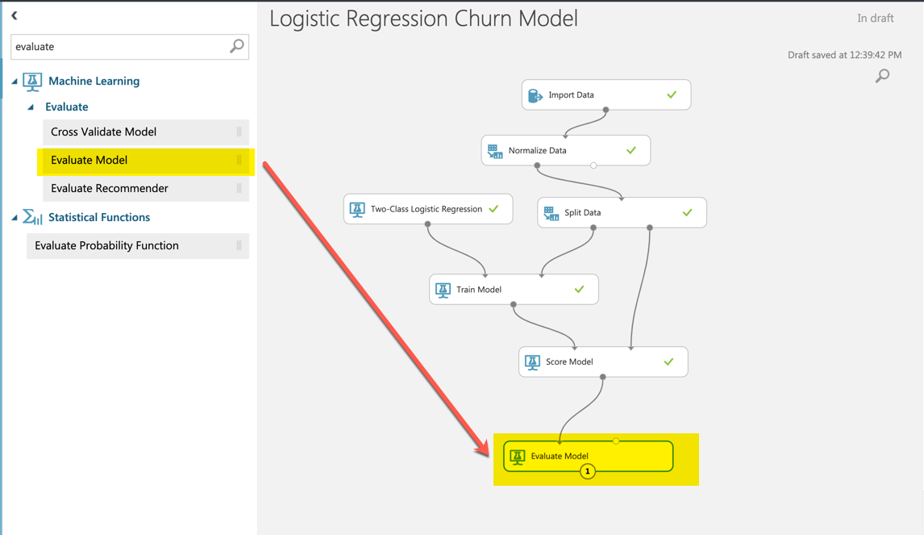

1. Run the experiment
2. Right-click on the Evaluate model to view the performance of the model as seen in the following screenshot:

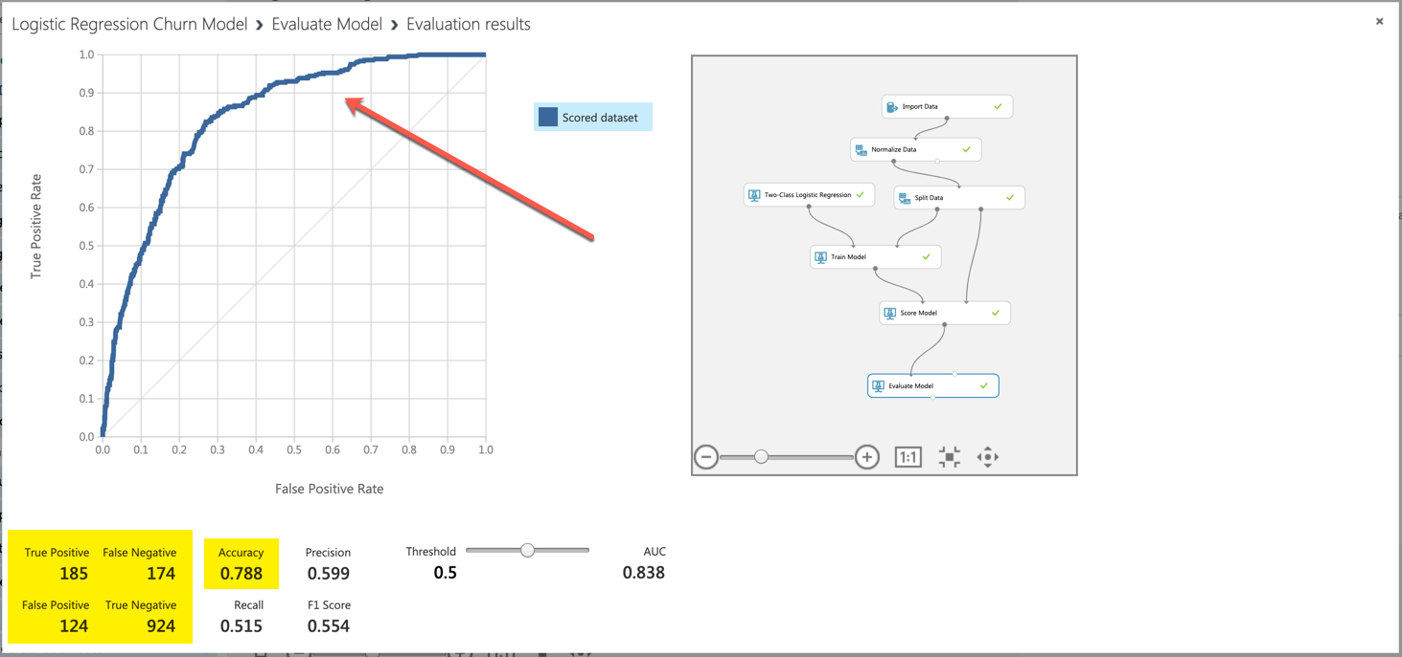

1. We see a few of the following metrics to evaluate our model
   1. [ROC Curve](https://en.wikipedia.org/wiki/Receiver_operating_characteristic)
   2. [AUC Score](https://stats.stackexchange.com/questions/132777/what-does-auc-stand-for-and-what-is-it)
   3. [Confusion Matrix](https://en.wikipedia.org/wiki/Confusion_matrix)
2. We are now ready to export our Scored Dataset back to blob storage using the **Export** **Data** Node as seen in the following screenshot:

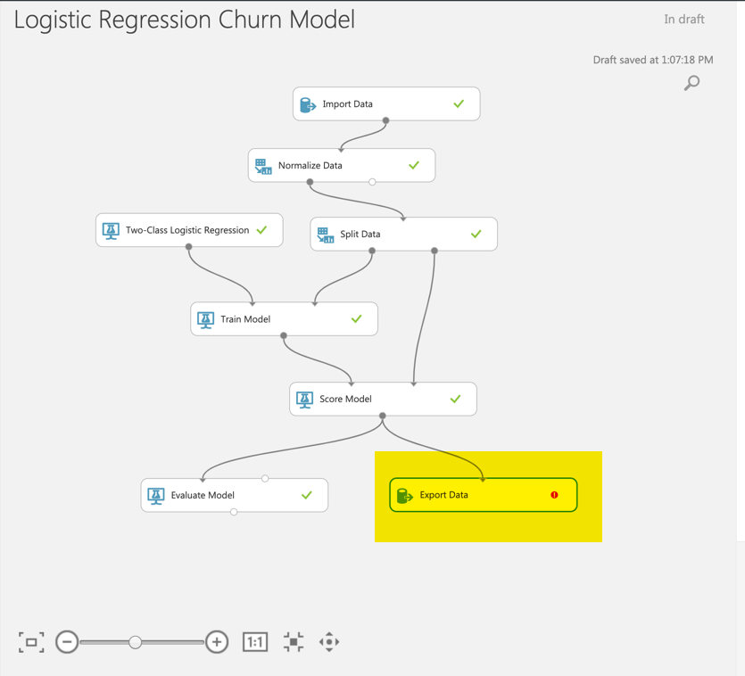

1. Enter the same credentials as you did in the previous section when exporting the scored results as a CSV file. However, this time we will name the file path **churn/Telco_Customer_Churn_Final.csv** as seen in the following screenshot:

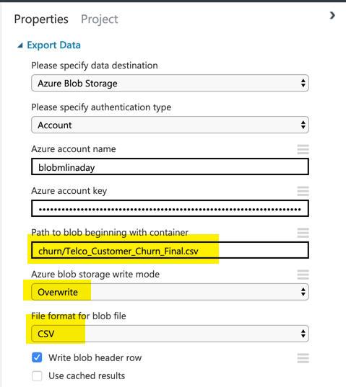

1. Run the Experiment
2. If you go to your blob storage account, you should now see your newly exported dataset with the scored results as seen in the following screenshot:

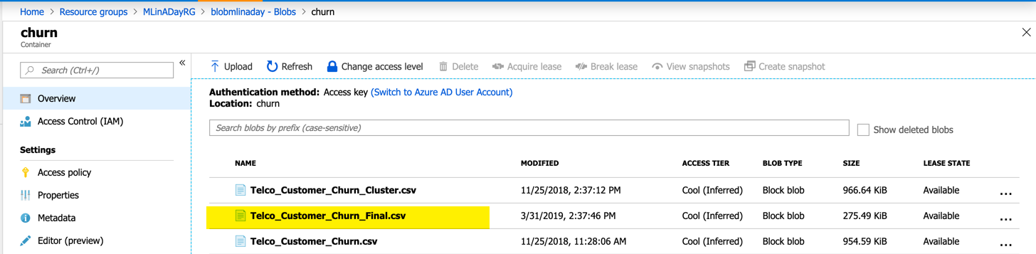

## Section 6: Export scored dataset with prediction scores from Blob to Power BI Desktop

1. Start up Power BI Desktop and select Get Data as seen in the following screenshot:

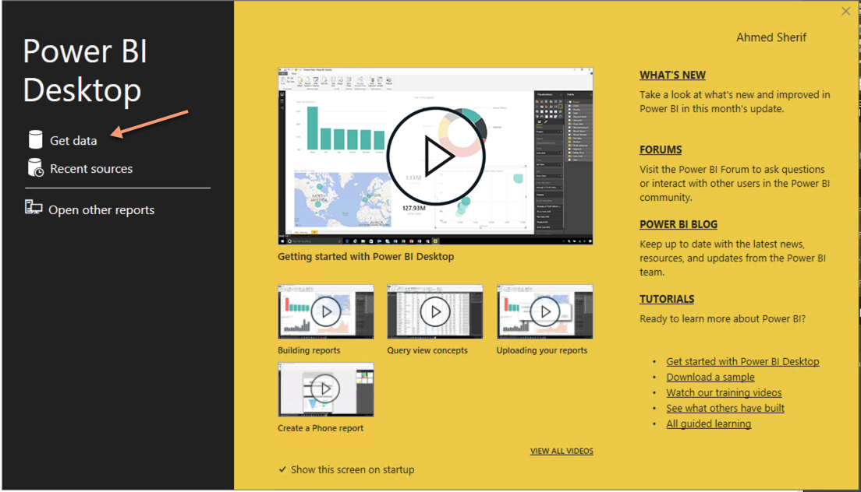

1. Select **Azure** and then **Azure** **Blob** **Storage** as seen in the following screenshot:

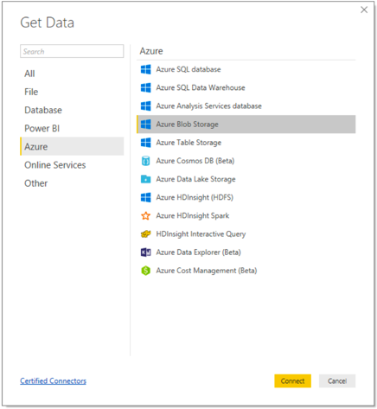

1. Enter your Blob Account Name and select OK

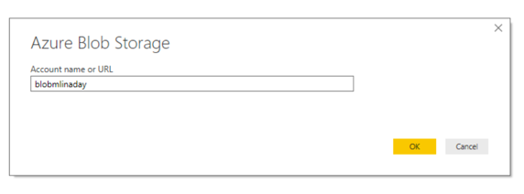

1. Enter your blob account key and select OK

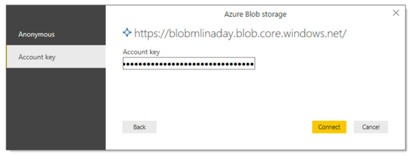

1. You will see all of your files in the container you’ve selected as seen in the following screenshot:

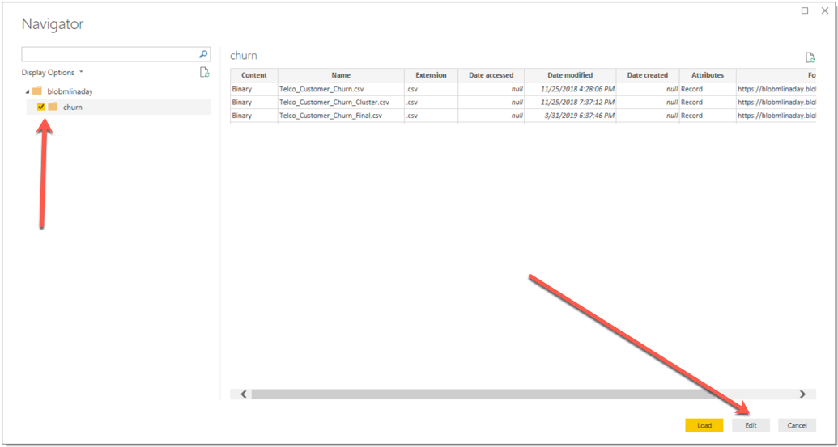

1. Do not select Load, but instead select **EDIT** and then select the **double** **arrows** next to content as seen in the following screenshot:

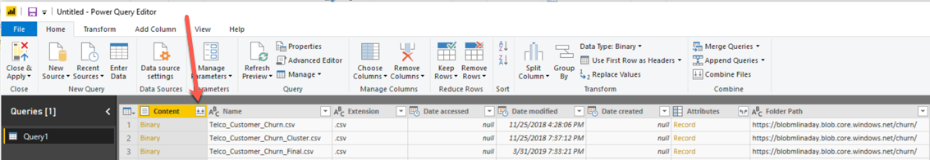

1. Select Telco_**Customer**_**Churn**_**Final**.**csv** as the Example File as seen in the following screenshot:

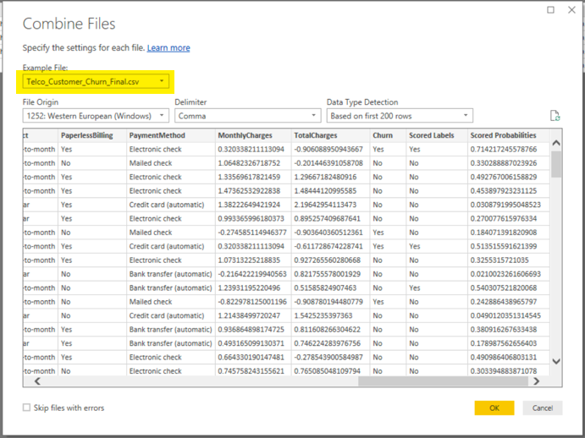

1. Select OK
2. Scroll all the way to the end of the last column and select on the **Scored** **Probabilities** column. Right-click on it and select **Change** **Type** to **Decimal** **Number** as seen in the following screenshot:

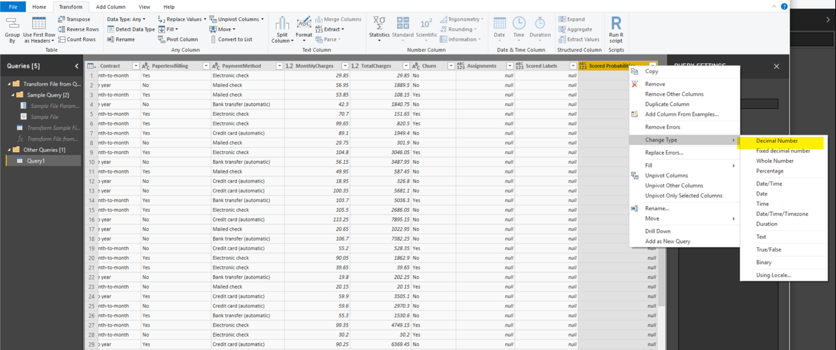

1. Select Close and Apply and return to the main Power BI canvas
2. Once all of that has been accomplished, the dataset with all of the columns will be available for us to visualize inside of Power BI as seen in the following screenshot:

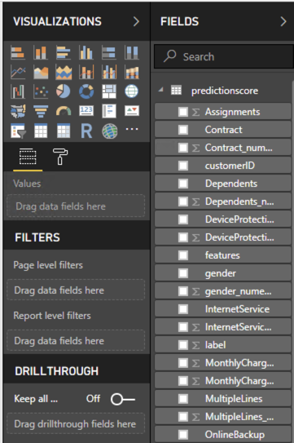

1. We can build a heatmap showing how accurate our model is within different segments of the population. Select the Matrix visualization from the Visualizations bar.

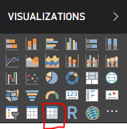

1. Drag **Assignments** into the Rows area. These **Assignments** represent the 10 customer segments we created in Azure Machine Learning Studio. Next, Drag **PaymentMehod** into the Columns area. Drag **Scored Probabilities** into the Values area.

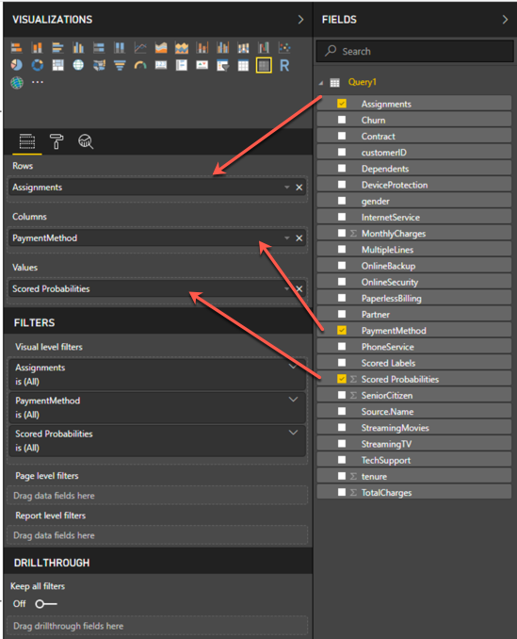

1. Right click on **Scored Probabilities** in the Values area and select **Average**.

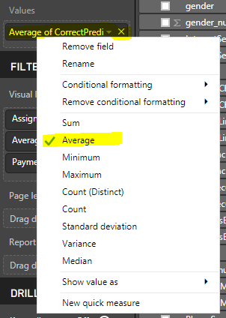

1. Right click on **Average of** **Scored Probabilities**, which now appears in the Values area, but this time select Conditional formatting and Background color scales.

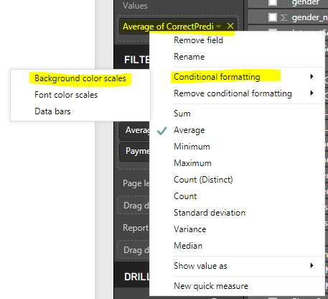

1. We now have a heatmap showing how accurate our predictions are within each customer segment and for customers of each payment type.

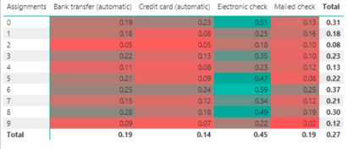

1. We have successfully completed this workshop!! Feel free to play with other visualizations in Power BI while fellow participants finish up.